Name: Suying Tu

ID: 33095213

Lab: Wednesday 4pm

Tutor: Songhai (Frank) Fan

Task 1:

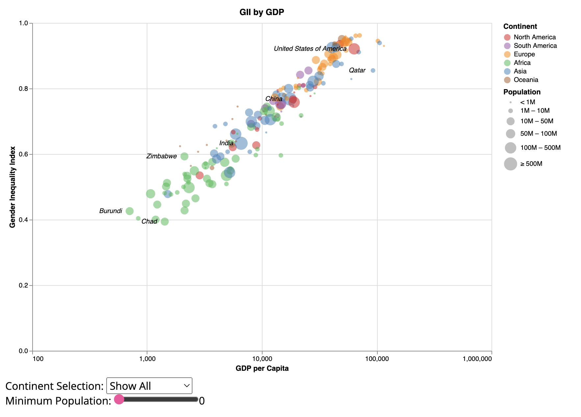

Task 2: <https://stuu0004-monash.github.io/Week10HW/>

Domain: Gender Inequality

Attribute types: qualitative (population, GDP, gender inequality index), qualitative (continent, country)

Source and Author: United Nations

Justification: Bubble chart because it allows the reader to see countries with a larger population more easily since they are more significant.